Homework #8

Where to put all that hair.

Task One:

You are to draw one of the faces below.
Use the guide to help you.

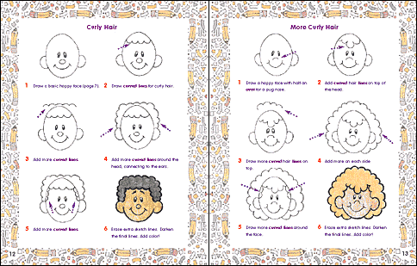

Draw Here

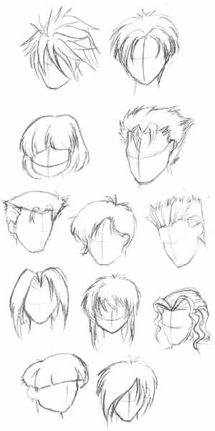
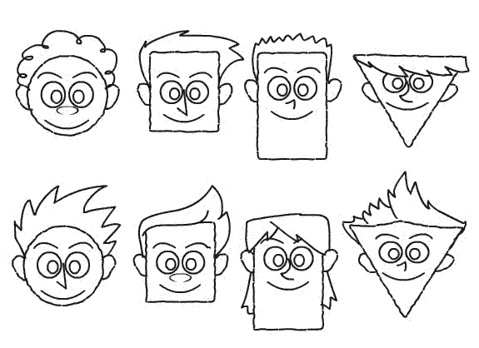

Use the examples above of hair to help you draw your own character
Draw your own character with hair below.

